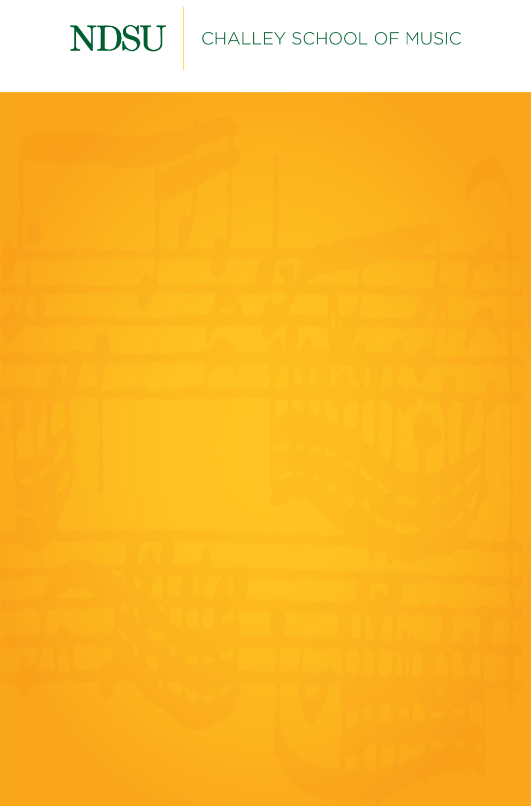
Name, Instrument
Name, Instrument

[Day of the week], [Month] [Day], [Year]
[Location]
[Time]

Delete italic lines before submitting
For works with composer:
Title Composer
(1000 – 2000)
Performer, Instrument

For works with arranger:
Title Composer (1000 – 2000)
arr. Arranger
Performer, Instrument

For works with living composers:
Title Composer (b. 1000)
Performer, Instrument

Intermission

Title Composer
(1000 – 2000)

Title Composer
(1000 – 2000)

Title Composer
(1000 – 2000)

NDSU Division of Performing Arts

Upcoming Events
Scan the QR code below or click here to view upcoming events with NDSU Performing Arts. All events are subject to change. Always check the calendar for current information before attending any event.
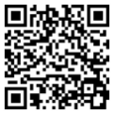

NDSU Performing Arts Box Office
701.231.7969 | ndsu.showare.com


