- Go to Bison Advise
- Click “Login with NETID”
- Enter in your NDUS Credentials and click Log In.
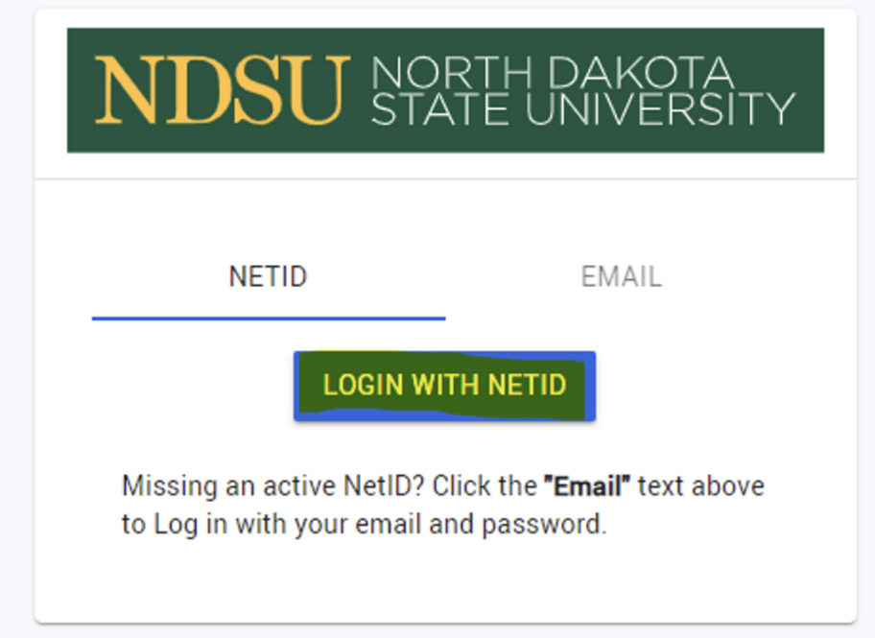

- From the left sidebar menu, click the “Tutoring” icon

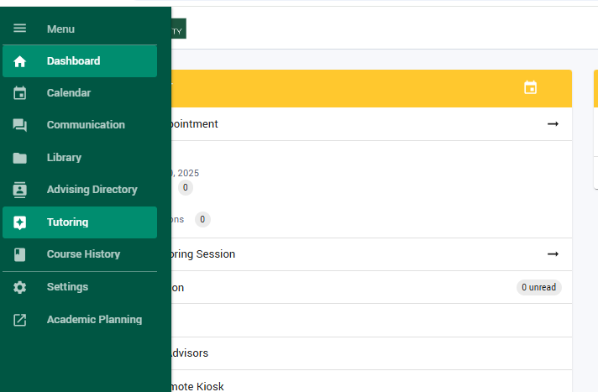

- At the far-right top corner of the opened webpage, click on the Create icon.
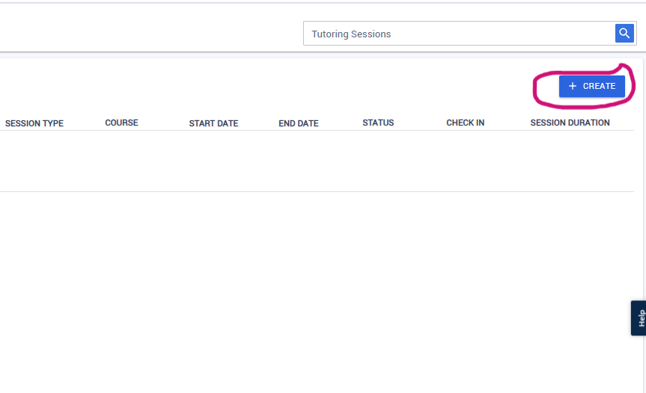

- Once you have clicked on create, a Modal dialog titled; “Create Tutoring Session” appears.
In the Service area, select “Tutoring at ACE” from the dropdown menu.

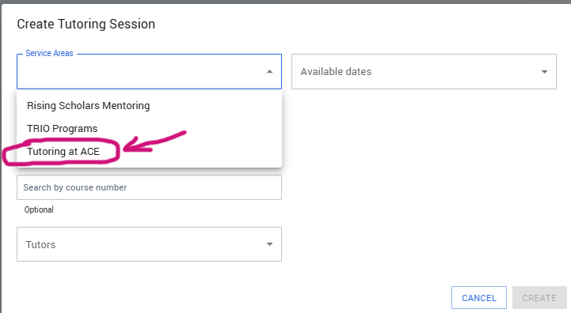

- Proceed to select a session type (ACCT, MATH, CHEM, COMM or others) and enter the specific course number for which you are scheduling the appointment.
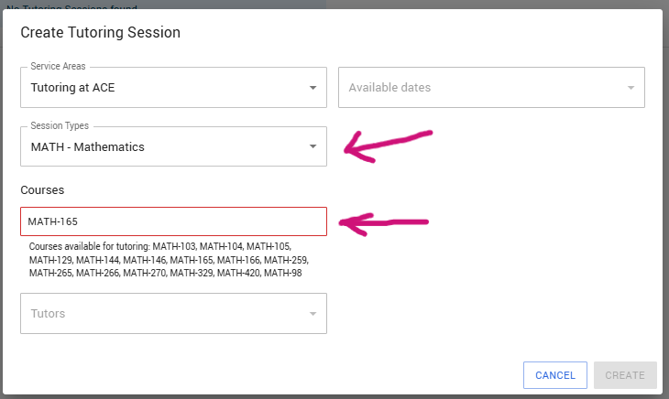

- Choose a Tutor to see their available dates and select the most favorable time that works per your schedule, from the dropdown options. Then “Click on Create”
