
Variability Rate Fertilization Profitability Study
Develop a regional database of up to 100 fields to compare variable rate application of fertilizer with whole field rate application. Ask farmers to participate in the program – allowing each to collaborate with two fields. The farmer will supply basic information about the fields, use variable rate application and yield monitors. NDSU will assist in developing zone maps, application maps and evaluate the data.
Our objective is to compare both nitrogen use efficiency and yield between variable rate and whole-field rate nitrogen fertilization for each participating field. Fields will be zoned using NDVI from Landsat imagery (or by an alternative method that individual farmers prefer, such as previous years’ crop yield, topography, or EC). Each zone will have two 2 acre plots fertilized at the whole field rate (based on a composite of the zone soil samples). The fertilizer rates for each zone will be based on soil tests for each zone and the farmer-selected yield goals.
Farmer Responsibilities
- Two fields per producer.
- Supply geographic description of each field. (options: latitude and longitude of field edges, legal description, field boundary)
- Supply cropping history for each field. (Provide as many years of history as possible).
- Indicate the planned crop and yield goal for the entire field.
- Soil sample and test each field zone, and do a composite soil test.
- Apply variable rate nitrogen fertilizer, indicating the type of fertilizers used.
- Provide an as-applied map to NDSU.
- Harvest the fields with a yield monitor and share the data with NDSU.
NDSU Responsibilities
- Assist the farmer to prepare zone and fertilizer application maps. Each zone will include 2-acre randomized plots fertilized at a constant rate based on the field composite soil test results.
- Provide application maps to the farmers in their desired digital format.
- Analyze the data and share results.
Analysis Procedures
Nitrogen Use Efficiency (We will calculate this separately for each variable rate zone and for the whole-field zone.)
Residual N before planting + applied N – residual N after harvesting = N used
N used / Yield = N require per bushel
Yield Comparison
Total bushels produced on the entire field.
Total bushels that would have been produced based on the whole-field check plots.
NDSU Variable Rate Study: Procedures
The first step is to divide each field into management zones. You can make the zones yourself, or we can do it for you. If you prepare the zones, email the zoned fields to me. They can be in a shapefile, an image file or in any other proprietary format you normally use. We will add two 2-acre check plots inside each variable rate zone and return the maps to you.
If you want us to prepare the zones, email a description of the fields to me. You can send a legal description, shapefile, or other digital format of the field. We will prepare the zones using satellite imagery from previous years. Please include what was grown on the fields in previous years. We will email the zoned field maps back to you.
The second step is to soil test each zone. Sample each zone separately. Have each zone analyzed separately, and have a composite sample analyzed. The composite sample analysis, a mixture of the zone samples, will be used to determine the fertilization rate for the check plots in each zone.
The third step is for you to select the crops and yield goals for each field. If you want assistance in this process please let me know. Our extension agronomists and soil scientist can provide consultation if you want it.
The fourth step is to determine the fertilizer rate for each zone, and for the check plots. I will send you NDSU’s fertilizer recommendations for the crops you intend to plant.
Sixth step, apply the fertilizer. After you apply the fertilizer and plant, please email the “as-applied” maps to me. I will use these maps in our analyses of the nitrogen efficiency and yield comparisons.
Finally, harvest each field with a combine equipped with a yield monitor and GPS unit. After harvest, please email the yield maps for each field to me.
Finally, it will be useful if you would soil sample each zone after harvest so we will know the residual nitrogen after the crop growth.
These are the analyses we intend to do for each field at the end of the season:
Nitrogen Use Efficiency (for each variable rate zone and for the whole-field zone.)
- Residual N before planting + applied N – residual N after planting = N used
- N used / Yield = N require per bushel
Yield Comparison
- Total bushels produced on the entire field.
- Total bushels that would have been produced based on the whole-field check plots.

Contact Information:
John Nowatzki: email John.Nowatzki@ndsu.edu Telephone 701-261-9842 or 701231-8213
Example of Variable Map

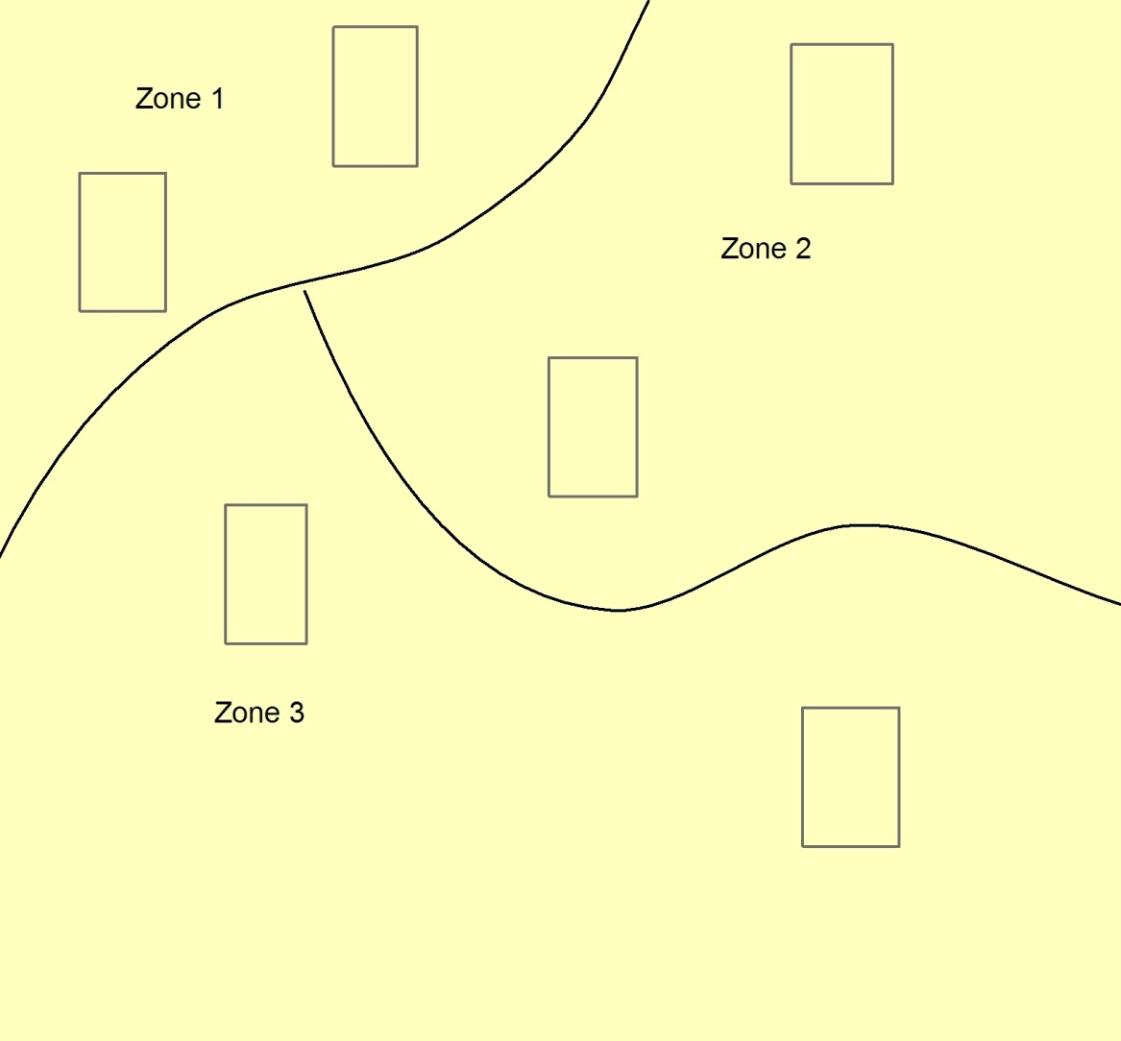
Composite Rate
Composite Rate
Composite Rate
Composite Rate
Composite Rate
Composite Rate

The composite fertilizer zones will be fertilized based on the soil test analysis from the test done on the soil sample made by mixing soil from each management zone.

Each zone will be soil sampled and tested separately to determine the required fertilizer. The grower selects the crop to grow and the yield goal for each zone.

